**Project name: Healthfirst Care initiative**

**Process Modeling**

Process modeling helps visualize workflows, identify inefficiencies, and redesign them for improved efficiency. This document outlines the *As-Is* (current) and *To-Be* (proposed) processes for key workflows at HealthFirst Care. The objective is to address operational challenges, reduce patient wait times, improve communication, and streamline overall hospital processes.

**Key Challenges Identified (from As-Is)**

* Manual appointment scheduling causing double bookings.
* Paperwork-heavy check-in process causing long queues.
* Communication gaps between admin, IT, and clinical departments.

**Rationale for Proposed To-Be Processes**

* Reduce wait times by **20–30%** using automation.
* Decrease manual data entry errors and improve resource utilization.
* Improve communication across departments using centralized platforms.
* Enhance patient satisfaction through digital interactions.

**As In Process-**

Appointment Scheduling Process-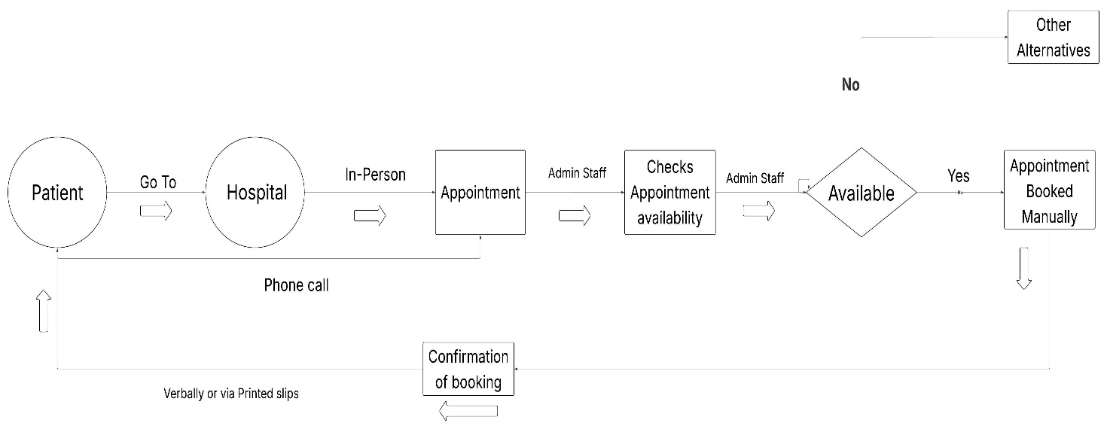

Patient Check-in Process-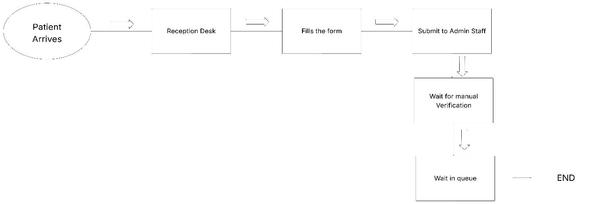Inter Departmental Communication-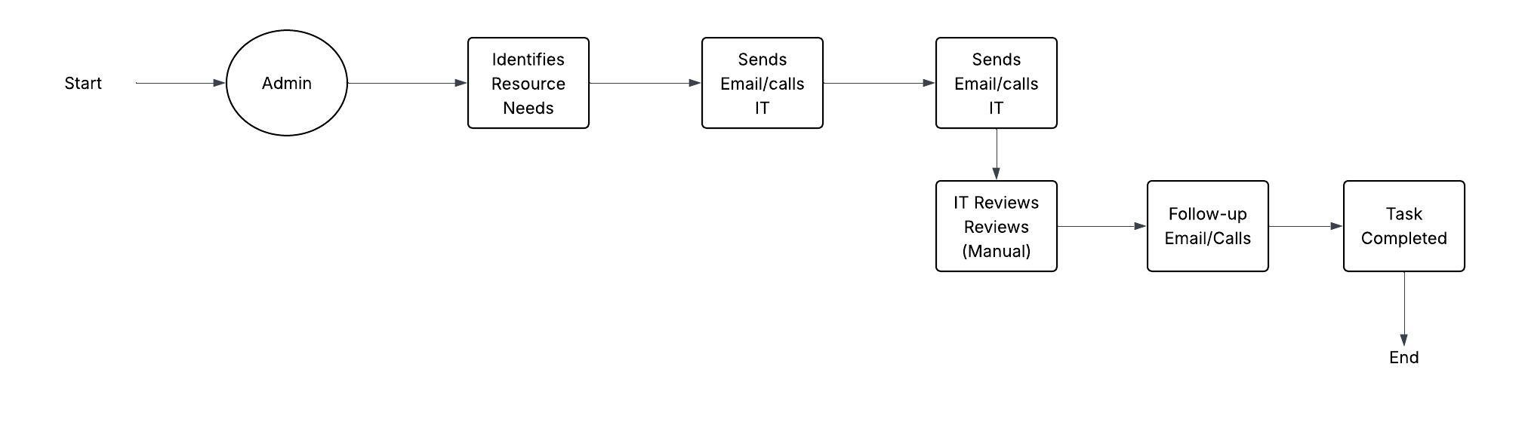

**To Be Process-**

Appointment Scheduling Process-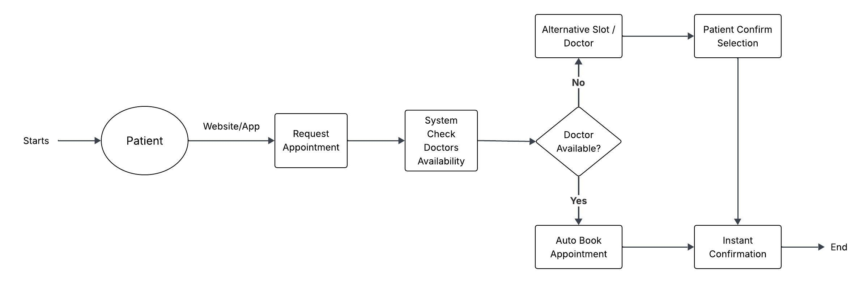

Patient Check-In Process-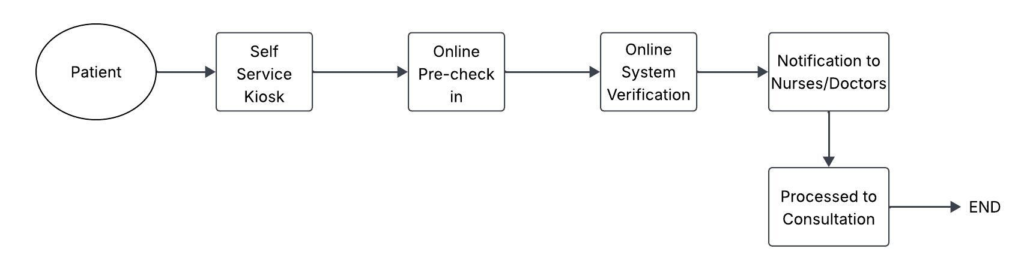

Interdepartmental Process-